**Cognitive Load and Psychological Safety**

Our human working memory, our capacity to learn and solve problems, is a system with limited capacity. The amount of information presented, any distractions in the environment, and one’s existing knowledge and capability all influence our capacity to problem solve and learn new information. This is why we can multi-task when we’re doing something we’re highly practiced at, but struggle to multi-task at anything complex.

–Intrinsic cognition is all the stuff you already know, such as how to make a decent cup of tea.

–Extraneous cognition is all the external stuff that you need to find out or understand, such as where someone left the teabags because you can’t find them. It also includes “noise” such as distractions.

–Germane cognition is active learning and problem solving. That’s the stuff of real value – such as comparing Tetley tea to Yorkshire Tea in a taste test to find out which is better.* It’s also the process by which learning is transferred from short-term to long-term memory.

By reducing and minimising extraneous cognitive load, you free up “working memory” or cognitive capacity to focus on problem solving and learning.

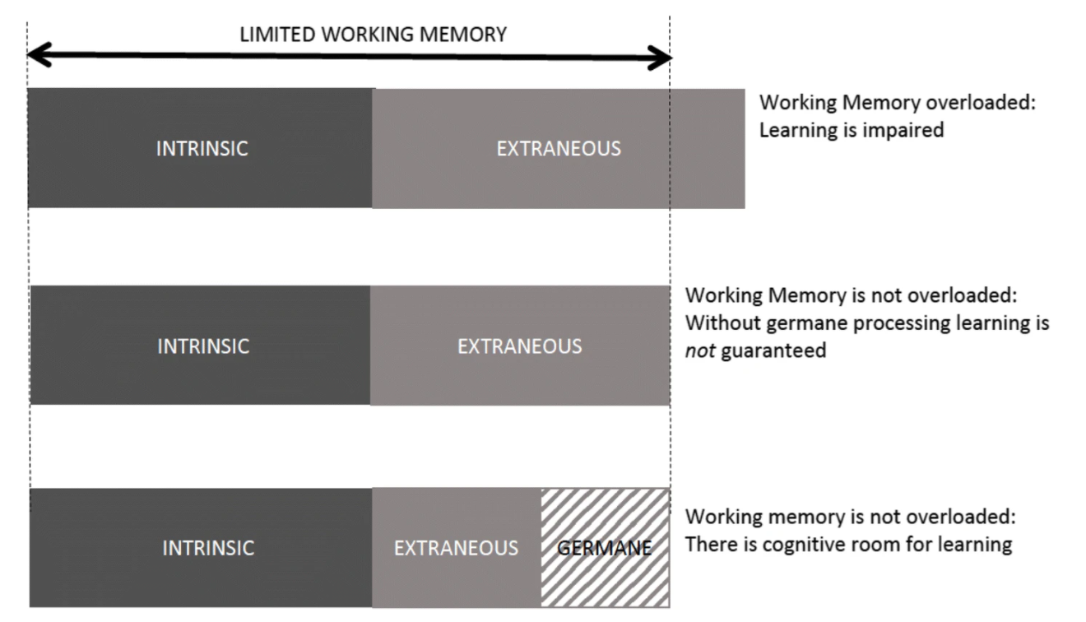

Cognitive load - intrinsic, extraneous, and germane

From Fraser, K. et al. (2018) “Cognitive Load Theory for debriefing simulations: implications for faculty development”, Advances in Simulation, 3(1). doi: 10.1186/s41077-018-0086-1.

The aim is to utilise one’s intrinsic cognition, minimise extraneous cognitive load, and maximise the potential for germane cognition.

**Psychological Safety**

A fundamental component of psychological safety is being able to speak up when you don’t know something and to ask questions without fear of embarrassment or shame.

The key point here is that asking questions is absolutely key to reducing extraneous cognition. Therefore psychological safety is critical in order to reduce extraneous cognitive load and maximise germane problem solving and learning. Even without actually needing to ask any questions, being in a psychologically safe enough environment that a team member knows they could ask questions should they need to, will help to maximise germane cognition and learning capacity.

Likewise, be careful when leading or training a group that you don’t overload extraneous cognition – “if participants feel they are being presented with too much information, this can create stress and potentially erode psychological safety.” (Madireddy, S. and Rufa, E., 2020)

**Maximise psychological safety and optimise cognitive load.**

High performing teams are constantly learning – whether from each other, through active learning, or from mistakes. It is through utilising the germane working memory that learning is optimised, so to maximise learning, and maximise performance, it is absolutely necessary to foster psychological safety and optimise cognitive load.

If you are in a position to control the workload and learning demands upon team members, be careful to optimise for maximum utilisation of existing (intrinsic) cognition, reduce extraneous cognitive demands as much as possible, and free up team members to maximise their germane, problem solving cognition.